Watt vs impedance in stereo mode:
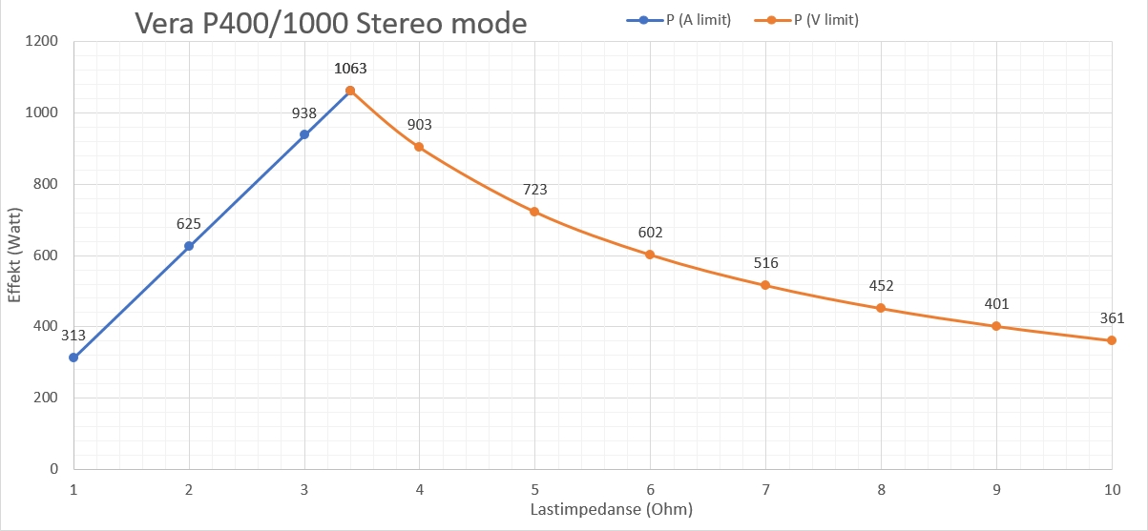

Watt vs impedance in bridged mode:
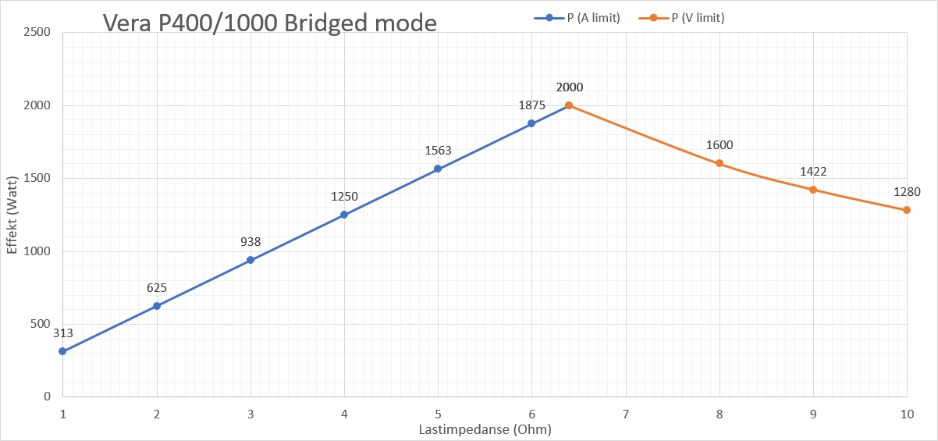

THD+N bridged into 8 Ohm load:
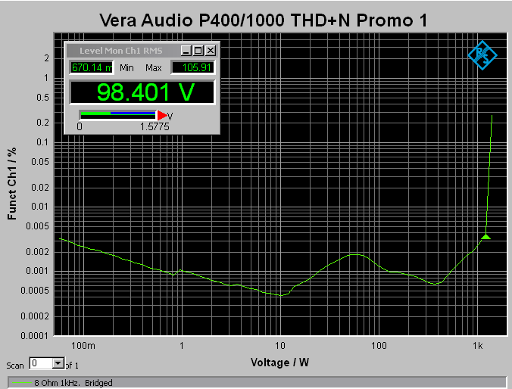
1210W into 8 Ohm with only 0.004% THD+N. 10W is at 0.0004% THD+N
Measured gain with gainsetting @ 21dB:
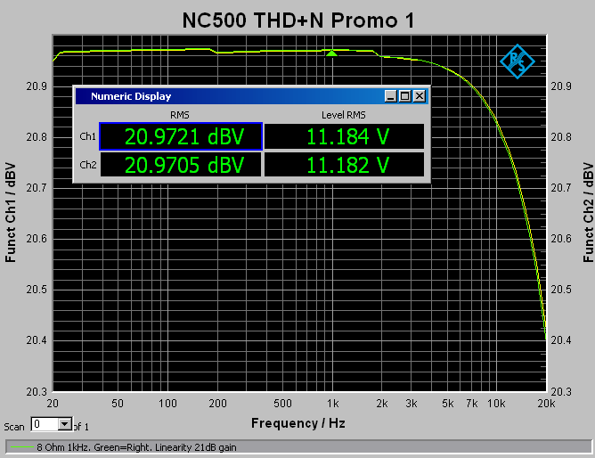
Gain matching is well within limits. Both absolute (0.03dB off) and between channels (0.0016dB off).
All the following measurements are for un-bridged mode.
THD+N 4 Ohm single ended
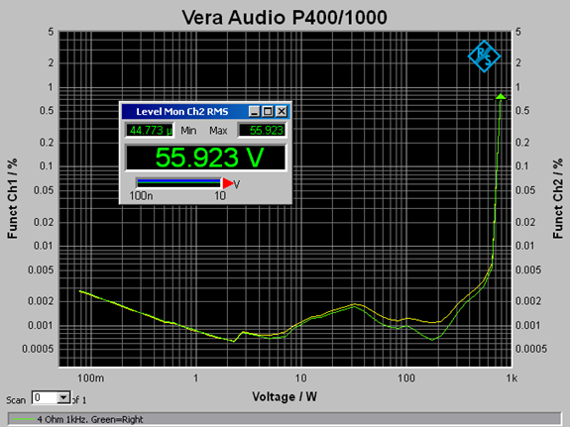
55.923V into 4 Ohm is 780W with 1% THD+N. About 650W with 0.006% THD+N
A closer look at what happens above 500W:
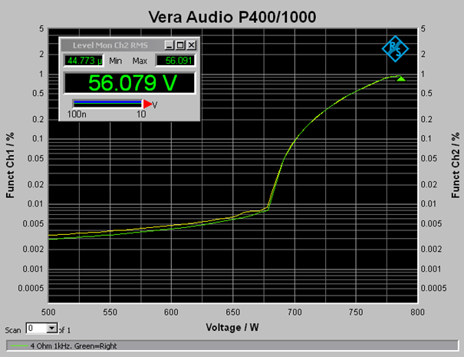
At 680W distortion starts to rise quickly.
S/N:
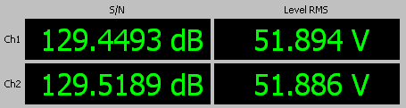
Signal to Noise is 129,5dB with 670W 4 Ohm.
SINAD 5W 4 Ohm:
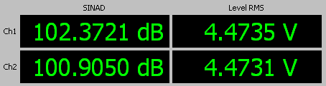

THD+N Spectrum 5W 4 Ohm:
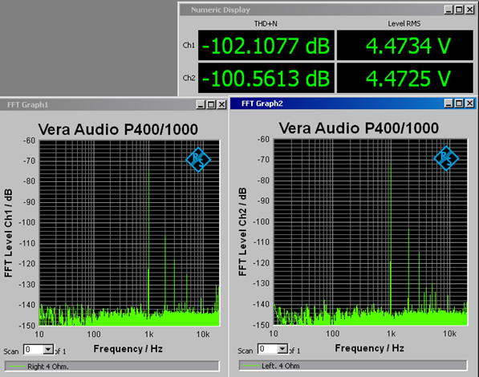

IMD 5W 4 Ohm:
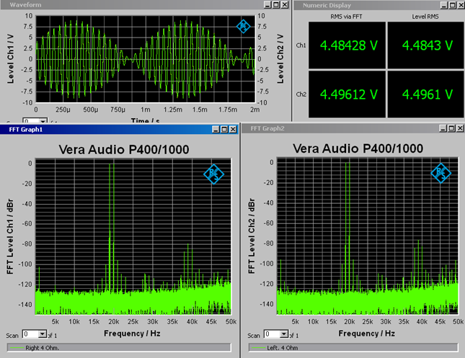
THD+N vs frequency. Bandwidth 61kHz, 1W 4 Ohm:
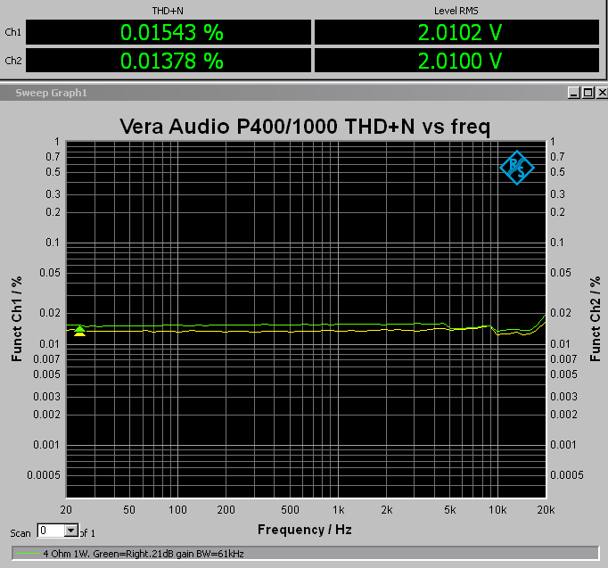
10W 4 Ohm:
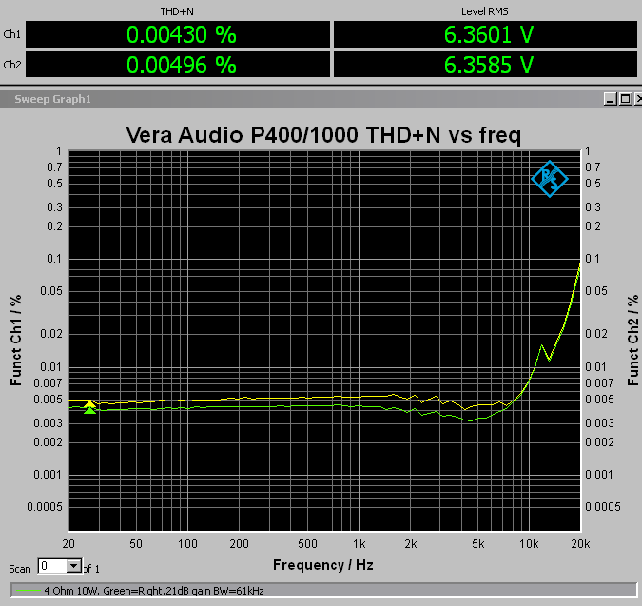
100W 4 Ohm:
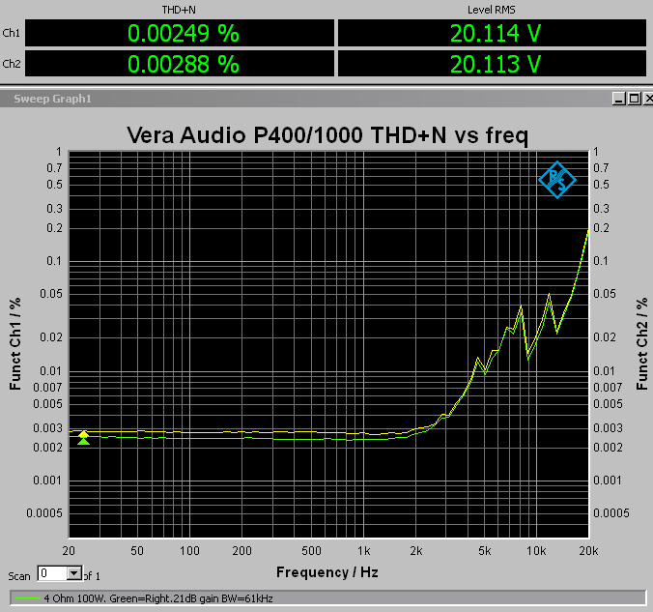
300W 4 Ohm:
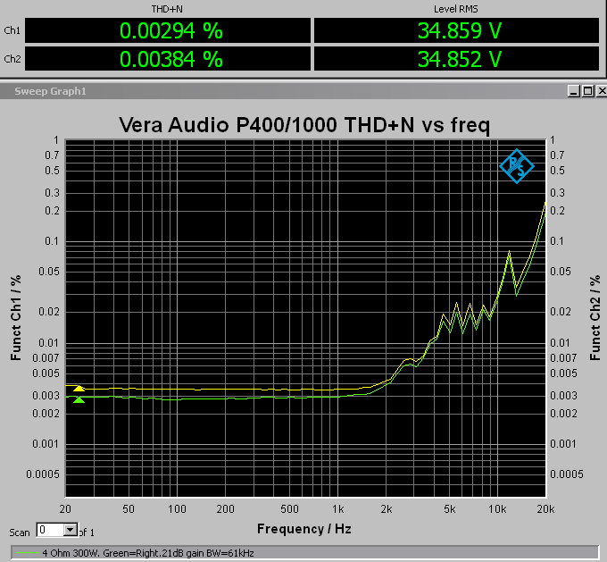
550W 4 Ohm:
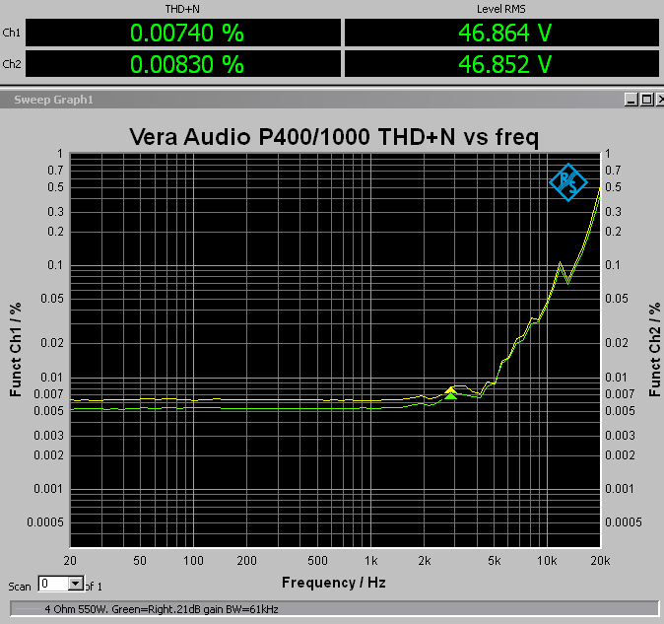
Same as above, but now with bandwidth 20kHz:
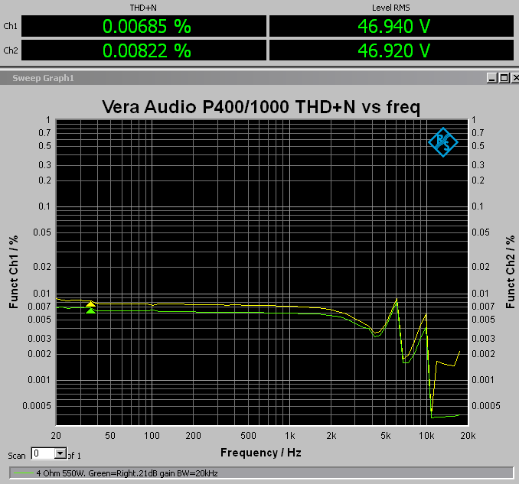
We can see that the harmonic components fall outside the upper bandwitdh of 20kHz. At 7kHz, third harmonic is 21kHz and falls outside the measurement. Ar 10kHz second harmonic is 20kHz and is also removed.

CMRR.
We have put effort into having high CMRR.
Here measured the CMRR with a 1V CM signal:
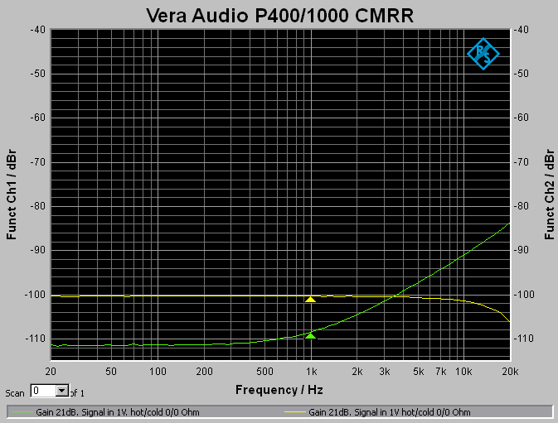
This is without source resistance on both phases (hot/cold). We can see a relatively large discrepancy between the channels. This is due to resistor differences in the buffer. This is what you get with 0.004% tolerance. The right channel is extremely good at low frequencies so the resisor values must be much tighter the 0.004% in this channel.
Adding 10 Ohms to the HOT phase gives ut this:
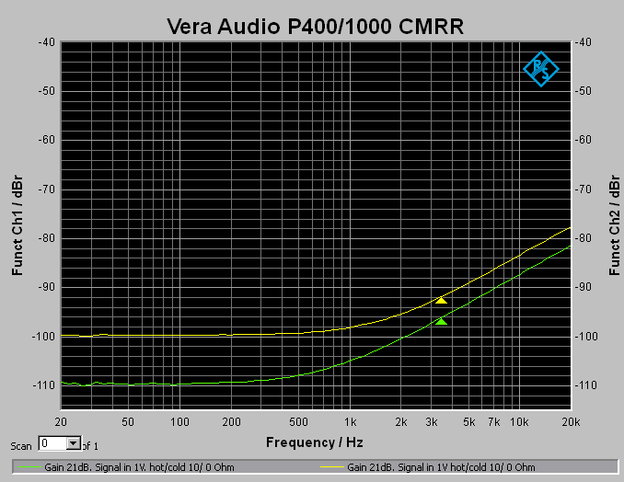
Left channel now rises above 1kHz too.

Adding 10 Ohms to the COLD phase gives ut this:
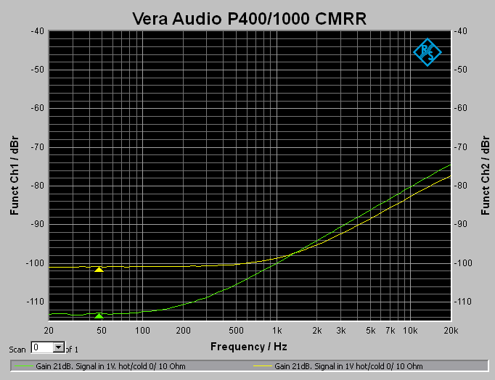
Right channel did nok like this, but it is still at 100dB CMRR at 1kHz.
Worst result at 1kHz of the three CMRR tests above is used. This is left channel with 98dB CMRR.
Fine-tuning of the resistors on left channel could have led to better results on this channel, but 98dB is what you get with 0.004% resistors.

